How to Write a Literary Analysis Paper
Have a topic in your mind. It’s okay if it’s vague at first; it will get clearer later.
Search the text to ﬁnd key details, images, scenes, phrases or statements, structures, or narrative techniques that pertain to your topic. Describe the details, images, scenes; summarize the structures, techniques; all in your own words. Quote the phrases or statements; quotes should not stand alone and should be incorporated into your prose.
Analyze your evidence through close, careful reading. Avoid very general conclusions that might pertain to the entire novel (“The Vegetarian is a novel about violence”; “The Field of Life and Death explores age-old questions of suffering and resilience”). Interpretative questions ought to guide the analysis of your chosen evidence: Is there a relation between literary style (diction, syntax, tone, use of ﬁgurative language) and the meaning of the text? Is there a relation between literary structure (formal organization of scenes or plot events) and the meaning of the text? Why are these particular images or details represented in this way and not in another way? Who is speaking in the text (narrator, character, society, tradition) and why does this matter? Is there more than one way to interpret the detail, image, phrase, or scene in question, and how do these different levels of meaning work together or pull apart? How do these pieces of evidence speak to one another, do they build up layers of meaning, do they contradict each other? Is there anything ambiguous, and why does the ambiguity matter (always ask the latter question, and do not just point out an ambiguity without explaining its signiﬁcance)?
Keep in mind that you are arguing ﬁrst and foremost about a work of art. Maintain clear distinctions between characters, narrator, and author. Focus on the mode of representation; avoid sweeping claims about “society,” “history,” or “culture” that the text itself cannot verify. A literary text can suggest or critique aspects of its world, but it cannot prove them.
- (No) The Vegetarian tells us how women are oppressed in South Korea.
(Yes) The Vegetarian dramatizes the psychic and bodily consequences of oppression through Yeong-hye’s refusal to eat meat and the narrative’s fragmented point of view.
- (No) Lu Xun’s “Diary of a Madman” shows how feudal China was barbaric and backward.
- (Yes) “Diary of a Madman” uses the unreliable voice of its narrator and the metaphor of cannibalism to expose the moral paranoia produced by a decaying Confucian order.
As you analyze your evidence, you will begin to formulate your thesis statement—a single, precise sentence stating what you are arguing in this paper. State it explicitly in your opening section. Ask yourself: How does your selected evidence (maybe not all but a particular set of it) support one specific claim about your topic? The thesis should be concise (straightforward and not too long), unexpected (something that is unobvious and thus interesting), and afﬁrmative (not a question but an answer).
Next, develop a structure for your essay. Narrative evidence should appear in the paper in the order that the argument requires, not in the order of the plot. The paper should not be a list of all appearances of “theatricality” in the order that they appear in the text, for instance. Carefully select, group, and order your evidence in a convincing argumentative display. What is the best order in which to present these claims to your reader, so that the argument ﬂows in a logical and persuasive manner?
Option to consider counterargument to your argument. One good way to strengthen your analysis is to try and think of the best counterargument to your claim, provide this in a concise form towards the end of your argument, and then show why even a plausible alternative interpretation of your evidence does not defeat your argument.
Revisions. Good papers come from revisions not sudden bursts of inspiration. Writing is a process of refining your thinking. Have both yourself and others read your paper. Revise with the awareness that your reader loosely knows the work you are discussing but is not an expert in your particular analysis and interested in knowing more about the work and your thought. Maintaining this reader’s consciousness—the habit of anticipating how your writing will be understood—always improves clarity and flow.
Students almost never overexplain and always underexplain. So don’t be afraid of being detailed or specific. Elaborate. And further elaborate. They are not signs of weakness but marks of intellectual generosity. A strong paper is nuanced, descriptive, detailed, and strategic, showing not only what you think but how you think.
Finally, enjoy writing! Enjoy writing as a process of self-exploration and discovery, as a process of giving form and voice to what feels ineffable and fleeting. Treat it as a friend not a foe, someone who helps you understand your own thinking.
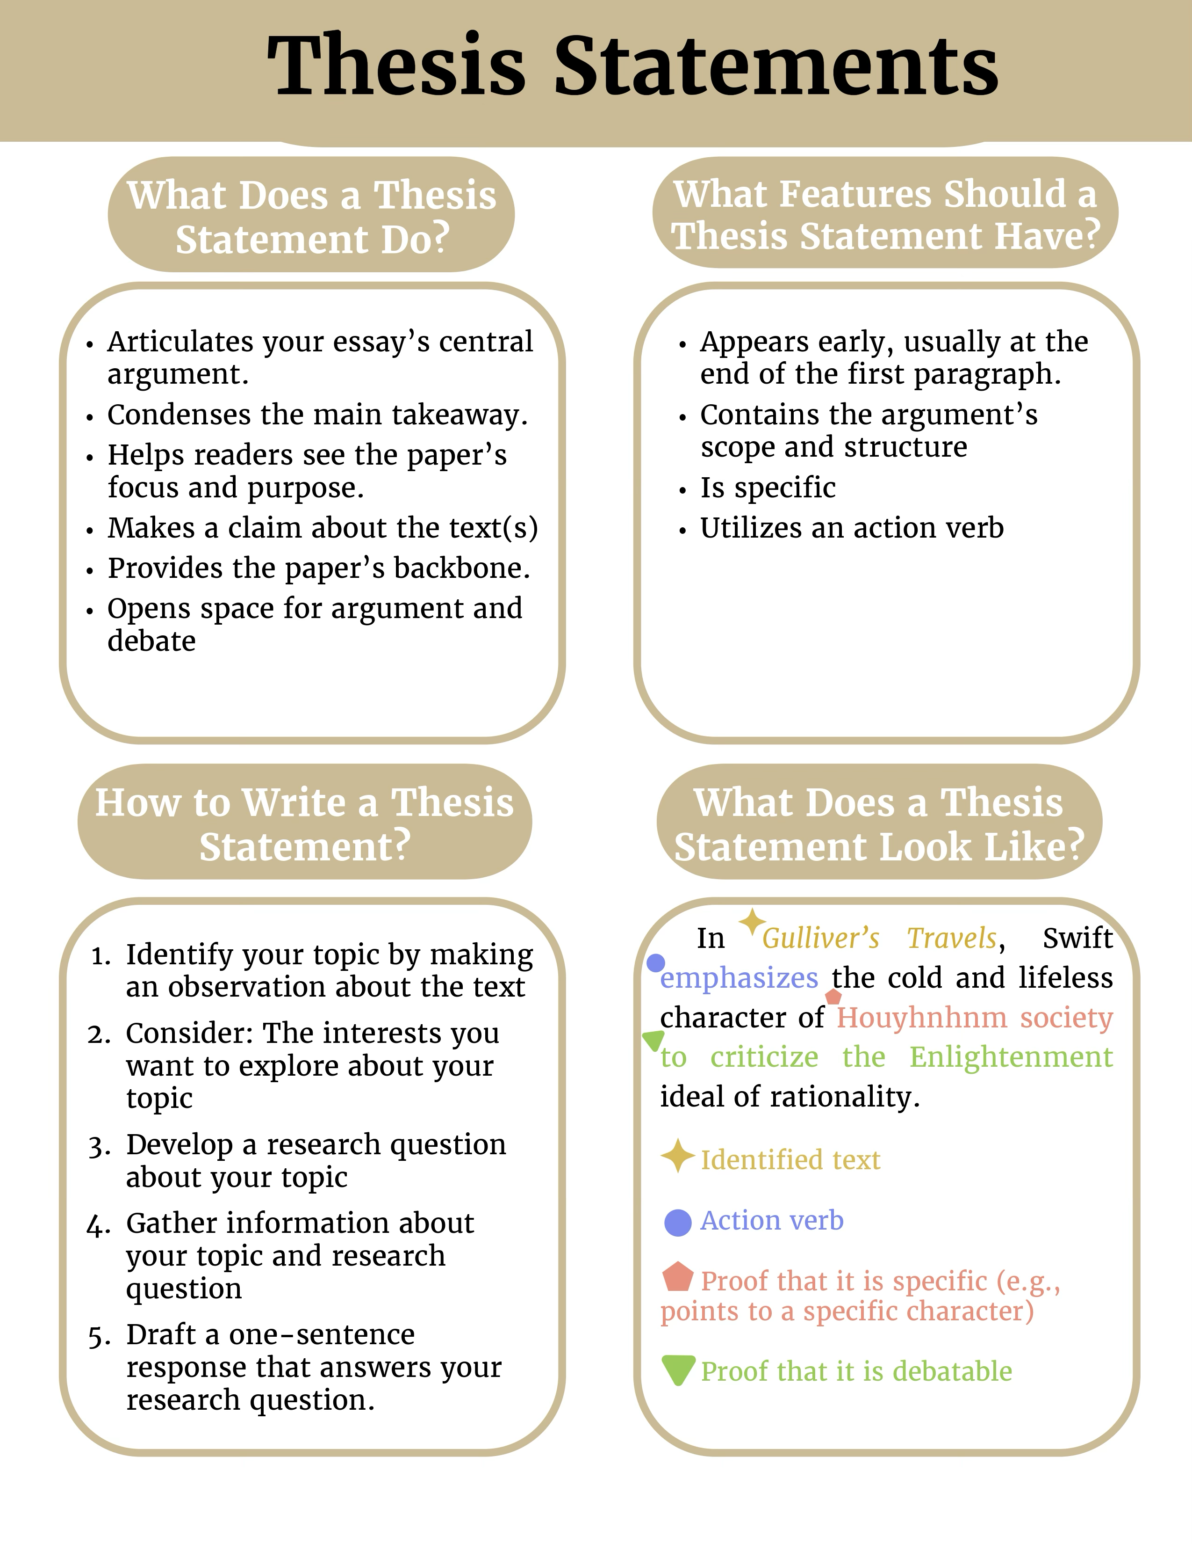

Thesis Statement Formula
One way I find helpful to explain literary thesis statements is through a "formula":
Thesis statement = Observation + Interpretation + Relevance
Observation: usually regarding the form or structure of the literature. This can be a pattern, like recurring literary devices. For example, "I noticed the poems of Rumi, Hafiz, and Kabir all use symbols such as the lover's longing and Tavern of Ruin" Interpretation: You could also call this an opinion. This explains what you think your observations show or mean. "I think these recurring symbols all represent the human soul's desire." This is where your debatable argument appears.
Relevance: this explains what the significance or relevance of the interpretation might be. Human soul's desire to do what? Why should readers care that they represent the human soul's desire? "I think these recurring symbols all show the human soul's desire to connect with God." This is where your argument gets more specific.
Thesis statement: The works of ecstatic love poets Rumi, Hafiz, and Kabir use symbols such as a lover’s longing and the Tavern of Ruin to illustrate the human soul’s desire to connect with God.

